NAME:PAREENITA A.SHIRSATH T.E.A.I.&.D.S. PRN:221101062 ROLL.NO:57

**SBL-CC EXPERIMENT NO : 6**

STEP 1: OPEN THE CONTROL ACCESS LISTS AND UPLOAD FILES.

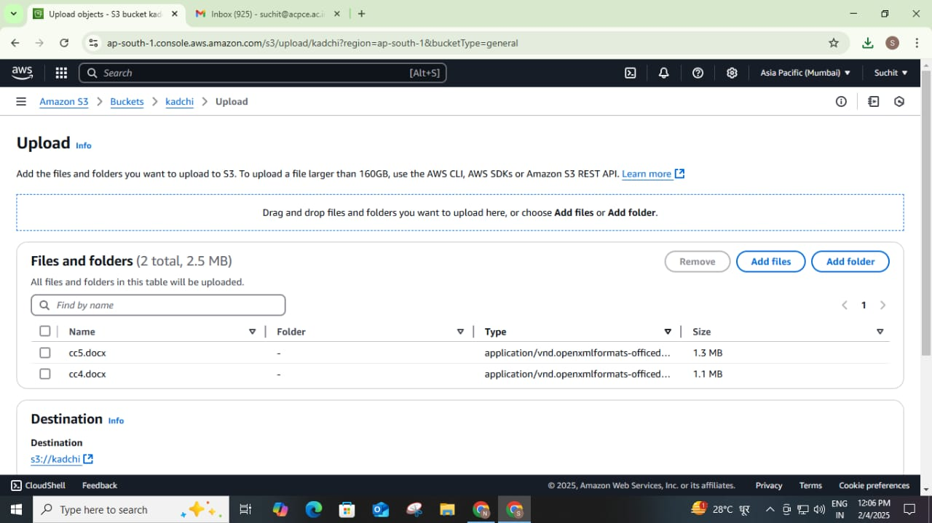

STEP 2: AFTER THAT NOW YOU HAVE CONTROL OVER WHO HAS ACCESS TO COMPANY RESOURCES.

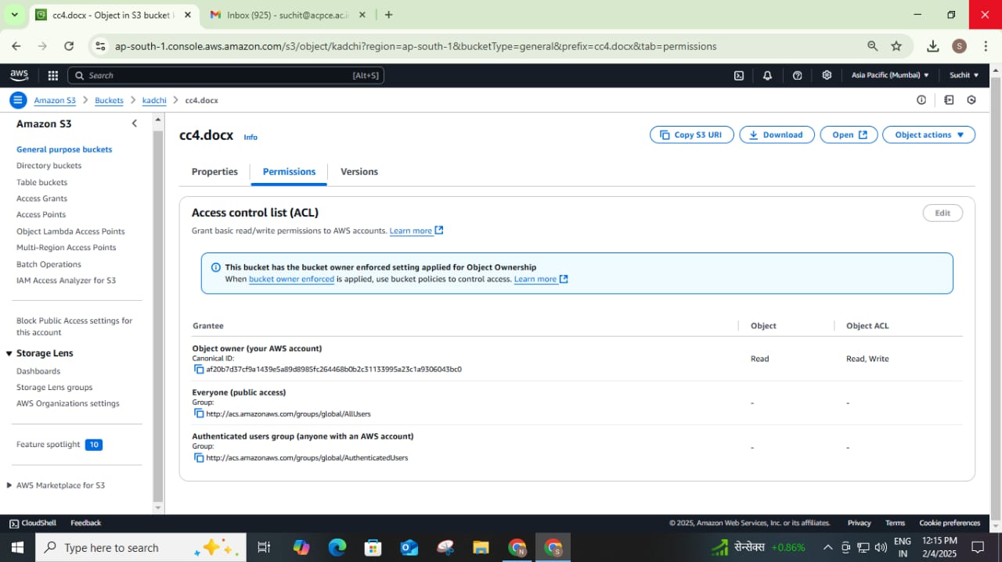

SECURITY AS A SERVICE USING I AM DASHBOARD.

STEP 1: OPEN I AM DASHBOARD AND ENTER DETAILS.

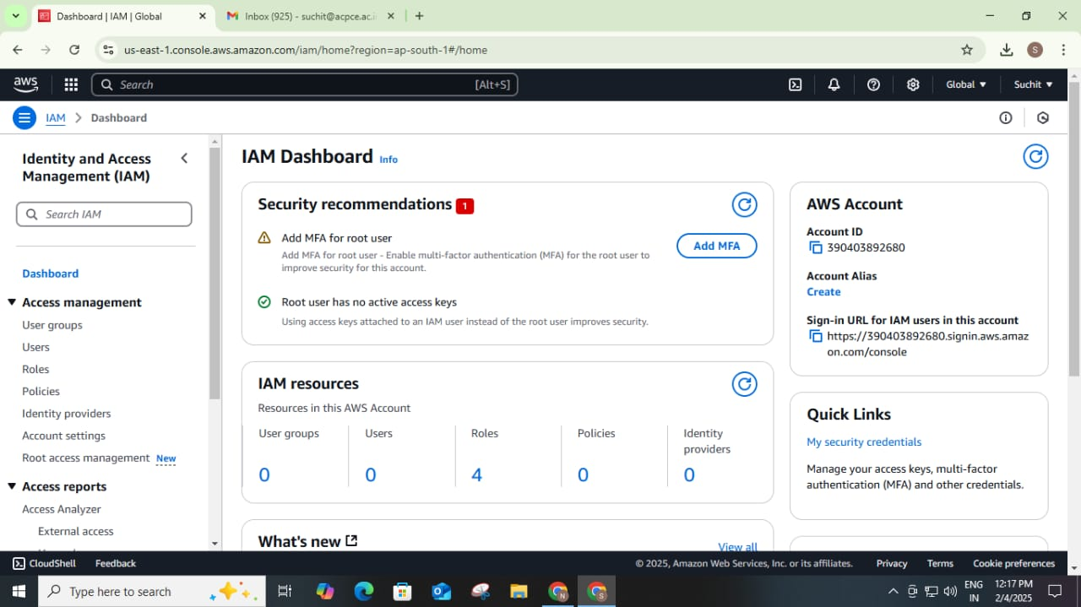

STEP 2: VERIFY WHICH USER HAS ACCESS OVER WHICH RESOUCES.

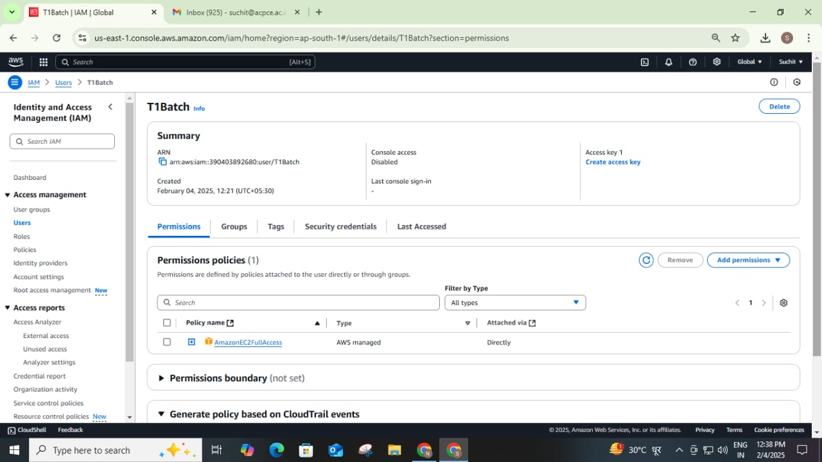

STEP 3: OPEN THE CONSOLE AND CHECK OUT THE PERMISSION AND SECURITY OVERVIEW OF ENTIRE SYSTEM.

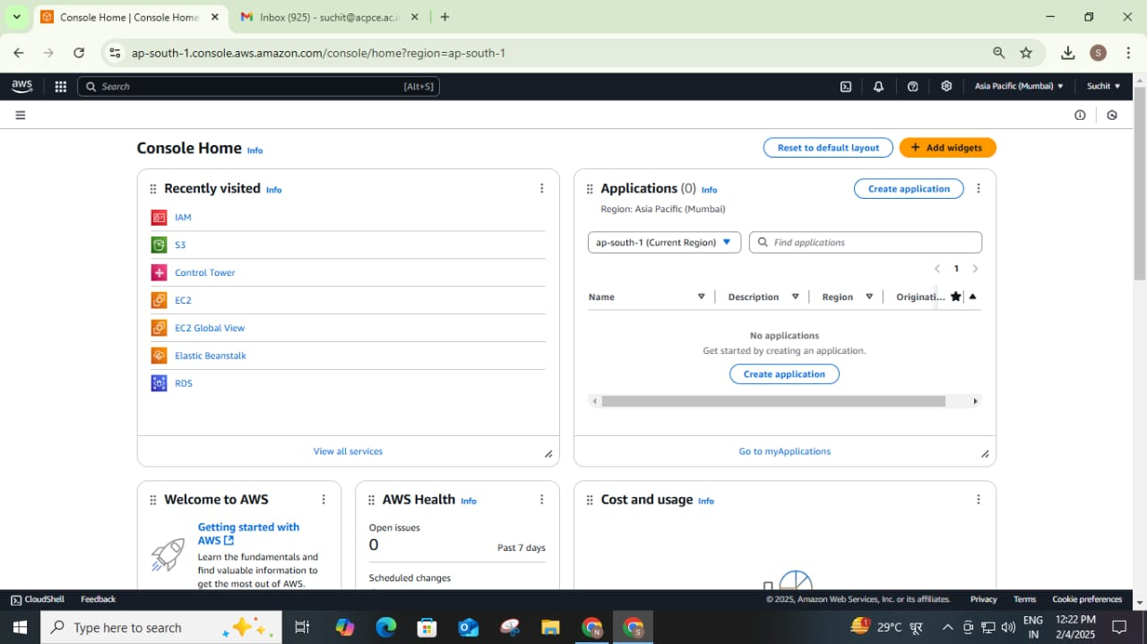

STEP 4: NOW YOU HAVE COMPLETE ACCESS AND AUTHORITY TO SEE WHO HAS ACESS AND ALSO WHO CAN ACESS THE COMPANY RESOURCE.



STEP 5 : USER CREATED SUCCESSFULLY.

